Official Entry Form Ford Mega Bass 2015
Ford Mega Bass hosted by Bass Champs on Lake Fork
For questions call: 817-439-3274
Early Entries will be accepted by mail with check but must be post marked by 3/11/2015
Make Check Payable to: BASS CHAMPS

MAIL YOUR ENTRY FORM TO: Bass Champs
Ford Mega Bass Event
PO BOX 89
Haslet, TX 76052-0089
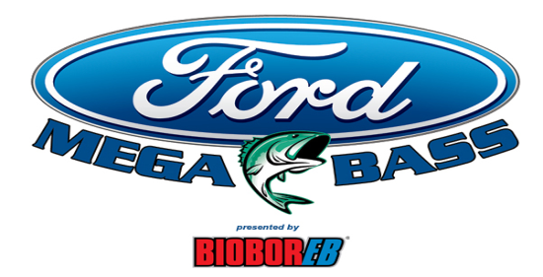

ONE TRUCK- EVERY HOUR
Lake Fork Sunday March 22, 2015

First Name: MI: Last: SS#: - - Address:

City: St: Zip:

DOB:

Cell Ph: Alt Ph: Brand of Tow Vehicle: Boat brand that you own: Motor: YR:
Email:

Entry fee: (NO CHECK ON SITE) CASH $160

CREDIT $170

Signature of Angler: X

I have read and understand the rules for the Bass Champs, Inc. (“Bass Champs”). Tournament circuit events. I have voluntarily completed this application and have included my entry fee to participate. I hereby agree to be bound by and comply with all tournaments, federal and state rules and regulations. I expressly assume all risk(s) associated with each tournament event and I hereby release Bass Champs, the host, all sponsors, and tournament officials, including, but not limited to each of their respective employees, officers, directors, managers, members, insurers and representatives (collectively “Releases”) from all claims or injury and/or damage arising out of, or related to and/or incurred in connection with any Bass Champs sponsored event(s). I hereby agree to indemnify, defend, and hold harmless Releases from and against any and all demands, claims, causes of action, (including, but not limited to, causes of action in contract, tort, strict liability or otherwise, and specifically including, but not limited to, any claim of negligence and/or fault of any Release) , fines, penalties, damages, liabilities, judgments, and expenses (including, without limitation, reasonable attorneys’ fees) incurred in connection with or arising out of my participation and my partner’s participation in any Bass Champs sponsored event. I hereby grant Bass Champs, the unconditional, royalty free, perpetual, right and license to use my name, voice, and photographic likeness in connection with Bass Champs promotions, television shows, and/or articles and press releases. I agree that I am not entitled to receive any royalties or other compensation in connection with such use. I further understand and agree that the tournament director reserves the right to reject my application for any reason. By signing this application I agree to submit to any truth verification testing requested by Bass Champs, and provided by a polygraph test selected by Bass Champs, and agree with the outcome of any such testing shall be final and binding. I agree that I have sufficient health, accident, and liability insurance to cover any bodily injury or property damage incurred by myself or others as a result of my participation in any Bass Champs sponsored event. If I have no such insurance, I declare that I am capable of paying for any and all such expenses or liability. I understand that I am responsible for paying all local, state, and federal taxes, title, license and registration as a result of my participation in any Bass Champs sponsored event. I agree that sole and exclusive venue for the determination of any claim or controversy arising out of or related to any Bass Champs sponsored events shall be in State District Court, Tarrant County, TX, where the principal office of Bass Champs is located. Should it become necessary for Bass Champs or any Release to incur attorney’s fees and costs to enforce this Release, I agree to pay the attorneys fees thereby expended, or for which liability is incurred. If this is a team event, I agree that my partner, if absent from signing this Release, understands all statements, rules, and regulations stated above and has given me express permission to sign on his behalf. By signing this Release, I am stating that my partner and I both agree to these terms.

